Machine Learning Models for Predicting Prognosis of Non-Small Cell Lung Cancer Based on CT Radiomics Features
Abstract
Objective: To evaluate and compare the prognostic value of deep learning-based and handcrafted radiomic features extracted from pre-treatment CT scans in patients with non-small cell lung cancer (NSCLC).Methods: This study retrospectively analyzed CT images and clinical data from 422 NSCLC patients. Two feature extraction strategies were implemented: (1) Swin Transformer, a hierarchical vision transformer for deep feature representation; and (2) handcrafted radiomic features derived using the pyradiomics package, including first-order statistics, shape, and texture (GLCM) descriptors. Feature selection was performed using LASSO regression. Three survival models—Random Survival Forest, Gradient Boosting Survival Analysis, and Cox Proportional Hazards—were trained using 5-fold cross-validation. A fusion model combining deep and radiomic features was also developed. Model performance was assessed using the concordance index (C-index), Kaplan–Meier curves, and time-dependent AUC. SHAP values were used to interpret radiomics-based model predictions.Results: Both Swin-based and radiomics-based models achieved competitive prognostic performance (C-index 0.626 ± 0.046), while the combined feature model yielded the best predictive accuracy (C-index 0.648 ± 0.047). SHAP analysis identified key radiomic patterns associated with poor outcomes. Kaplan–Meier curves confirmed significant survival differences between risk groups.Conclusion: Combining transformer-derived deep features with radiomic descriptors improves OS prediction in NSCLC. This multi-feature approach offers a promising tool for individualized prognosis and treatment planning.
Keywords: NSCLC; Radiomics; Swin Transformer; Prognosis prediction;

1 Introduction

Lung cancer remains the leading cause of cancer-related deaths worldwide, with non-small cell lung cancer (NSCLC) accounting for approximately 85% of all cases. Despite advances in diagnosis and treatment, the prognosis for many patients remains poor due to the heterogeneity of tumor biology and treatment responses. Accurate prognostic assessment is crucial for guiding personalized treatment and improving clinical outcomes.In recent years, artificial intelligence (AI) and machine learning (ML) techniques have shown great promise in oncology, especially in developing predictive models based on medical imaging data. Radiomics, which extracts high-dimensional quantitative features from standard imaging modalities such as computed tomography (CT), enables the characterization of tumor phenotypes noninvasively. These radiomic features have been associated with various clinical endpoints, including survival, treatment response, and tumor genotype. Parallel to radiomics, deep learning-based approaches such as the Swin Transformer have emerged as powerful tools for extracting hierarchical and spatial features from medical images in an end-to-end fashion.This study aims to compare two distinct feature extraction strategies—handcrafted radiomic features and deep features derived from Swin Transformer—for predicting overall survival (OS) in NSCLC patients using pre-treatment CT images. We further investigate whether combining both feature types into a unified model can enhance prognostic performance. All models were trained and validated using five-fold cross-validation, and evaluated by concordance index (C-index), Kaplan-Meier survival analysis, and SHAP-based model interpretation. Our goal is to explore the potential of multi-source image features to improve survival prediction and provide explainable, data-driven support for clinical decision-making in NSCLC management.2 Material and Methods

2.1 Data Description
This study utilized the publicly available NSCLC-Radiomics dataset from The Cancer Imaging Archive (TCIA), which includes thoracic CT scans, tumor segmentations, and clinical outcomes for 422 patients with non-small cell lung cancer (NSCLC). Baseline characteristics are summarized by histological subtype, including adenocarcinoma (n=51), large cell carcinoma (n=114), squamous cell carcinoma (n=152), and not otherwise specified (NOS, n=105). As shown in Table 1, the mean patient age was 68.0 ± 10.1 years, with 68.7% being male. Most patients presented with advanced clinical stages, particularly stage IIIb (41.8%). The majority had no distant metastases (M0: 98.8%). The mean overall survival (OS) time was 988.9 ± 1035.6 days. Significant differences were observed in age (p=0.009), T stage (p=0.007), N stage (p=0.016), and overall stage (p<0.001) among histological subtypes. This comprehensive dataset provides a robust foundation for evaluating machine learning models for NSCLC prognosis prediction.Table 1 Baseline characteristics of the non-small cell carcinoma patient population
 | Overall | adenocarcinoma | largecell | nos | squamouscellcarcinoma | p
n | 422 | 51 | 114 | 105 | 152
age(mean(SD)) | 68.0(10.1) | 67.3(9.6) | 66.9(10.2) | 66.3(10.0) | 70.2(9.9) | 0.009
clinical.T.Stage(%) |  |  |  |  |  | 0.007
1 | 93(22.1) | 12(23.5) | 18(15.8) | 38(36.5) | 25(16.4)
2 | 156(37.1) | 22(43.1) | 47(41.2) | 32(30.8) | 55(36.2)
3 | 53(12.6) | 9(17.6) | 11(9.6) | 10(9.6) | 23(15.1)
4 | 117(27.8) | 8(15.7) | 37(32.5) | 23(22.1) | 49(32.2)
5 | 2(0.5) | 0(0.0) | 1(0.9) | 1(1.0) | 0(0.0)
Clinical.N.Stage(%) |  |  |  |  |  | 0.016
0 | 170(40.3) | 18(35.3) | 32(28.1) | 57(54.3) | 63(41.4)
1 | 23(5.5) | 4(7.8) | 5(4.4) | 2(1.9) | 12(7.9)
2 | 141(33.4) | 15(29.4) | 48(42.1) | 28(26.7) | 50(32.9)
3 | 85(20.1) | 14(27.5) | 28(24.6) | 18(17.1) | 25(16.4)
4 | 3(0.7) | 0(0.0) | 1(0.9) | 0(0.0) | 2(1.3)
Clinical.M.Stage(%) |  |  |  |  |  | 0.443
0 | 417(98.8) | 50(98.0) | 112(98.2) | 103(98.1) | 152(100.0)
1 | 1(0.2) | 0(0.0) | 0(0.0) | 1(1.0) | 0(0.0)
3 | 4(0.9) | 1(2.0) | 2(1.8) | 1(1.0) | 0(0.0)
Overall.Stage(%) |  |  |  |  |  | <0.001
I | 93(22.1) | 11(21.6) | 15(13.3) | 44(41.9) | 23(15.1)
II | 40(9.5) | 8(15.7) | 5(4.4) | 4(3.8) | 23(15.1)
IIIa | 112(26.6) | 14(27.5) | 36(31.9) | 18(17.1) | 44(28.9)
IIIb | 176(41.8) | 18(35.3) | 57(50.4) | 39(37.1) | 62(40.8)
gender=male(%) | 290(68.7) | 32(62.7) | 71(62.3) | 75(71.4) | 112(73.7) | 0.161
Survival.time(mean(SD)) | 988.9(1035.6) | 1067.2(1165.7) | 1098.4(1107.2) | 1034.5(1117.9) | 848.9(854.1) | 0.208

2.2 Feature Extraction
Radiomics Feature Extraction and Transformer-Based Deep Feature Extraction were both performed to capture complementary characteristics of tumor regions from pre-treatment CT images. All images were preprocessed with resampling to a uniform voxel spacing (1×1×1 mm³) and intensity normalization prior to feature extraction.Radiomics Features Extraction was conducted using the open-source Python package PyRadiomics. Based on manually delineated tumor regions, a total of 518 handcrafted features were extracted for each patient. These features encompassed three main categories: First-Order Statistics, Shape-Based features, and Gray Level Co-occurrence Matrix (GLCM) features. Multiple parameter configurations were applied, including variations in bin width and spatial filters (e.g., wavelet and Laplacian of Gaussian), to enrich the feature space. Feature selection was performed using Least Absolute Shrinkage and Selection Operator (LASSO) regression to eliminate redundancy and enhance model interpretability.Transformer-Based Deep Features Extraction was carried out using a pre-trained Swin Transformer, a hierarchical vision transformer architecture designed for fine-grained visual representation learning. Tumor-centered CT slices were cropped and resized to fit the network’s input size. Deep features were extracted from the final embedding layer, yielding a 768-dimensional vector for each sample. These deep features represent high-level semantic information related to tumor morphology and were used directly as input to downstream survival models. In addition, a joint model was constructed by concatenating radiomic and deep features to explore the potential performance gains from multimodal feature integration.

2.3 Survival Model Development and Evaluation

To predict overall survival (OS) in non-small cell lung cancer (NSCLC) patients, we developed and compared three survival analysis models with specified hyperparameters: Coxnet Survival Analysis (with L1 ratio = 0.9, alpha minimum ratio = 0.01, max iterations = 10,000), Random Survival Forest (RSF; 100 trees, minimum samples split = 10, minimum samples leaf = 15), and Gradient Boosting Survival Analysis (GBSA; 100 estimators, learning rate = 0.1, max depth = 3). Random states were set for reproducibility.Prior to model training, feature selection was performed in a two-step process to reduce dimensionality and remove noisy features. First, a variance threshold filter was applied to remove features with near-zero variance across samples. Subsequently, the Least Absolute Shrinkage and Selection Operator (LASSO) regression was employed to further select informative features, with regularization parameters optimized via 5-fold cross-validation. This two-stage selection was applied separately to radiomics features and deep features extracted by the Swin Transformer.Models were trained and validated using stratified 5-fold cross-validation to ensure robustness and avoid information leakage. The concordance index (C-index) served as the primary metric to evaluate model discrimination for survival risk ranking. Additionally, Kaplan–Meier survival curves stratified patients into high- and low-risk groups based on predicted risk scores, while time-dependent area under the curve (AUC) analyses evaluated performance across follow-up periods.To improve interpretability, SHapley Additive exPlanations (SHAP) were applied to the best-performing radiomics-based model. SHAP values quantify each feature’s contribution to individual risk predictions, facilitating identification of key imaging biomarkers associated with prognosis. This approach promotes clinical applicability by elucidating the decision-making process of complex models in a biologically meaningful way.3 Results

3.1 Feature Selection Outcomes

To improve model robustness and reduce dimensional redundancy, a two-stage feature selection strategy was employed. First, variance thresholding was applied to eliminate low-variance features that are unlikely to contribute meaningfully to survival prediction. Subsequently, the Least Absolute Shrinkage and Selection Operator (LASSO) regression was used to further refine the feature space by imposing an L1 penalty, which shrinks less informative coefficients toward zero.This procedure was conducted separately on three feature sets: radiomics features, deep features extracted from the Swin Transformer, and the combined set formed by concatenating both. As shown in Figure 1, LASSO selected 33 features from the radiomics set (Figure 1a), 11 features from the deep set (Figure 1b), and 25 features from the combined feature set (Figure 1c). For visualization clarity, only representative non-zero coefficients are shown for the radiomics model due to the higher number of selected features.All selected features were subsequently used as input for model training and evaluation in the survival analysis pipeline.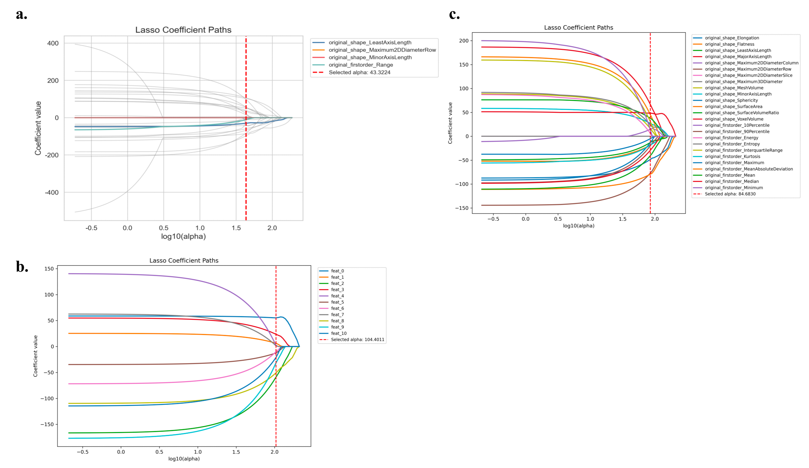

Figure 1 Coefficient paths in Lasso regression. (a)Radiomics features, (b)Deep features, (c)Combined features3.2 Model Performance
The predictive performance of the survival models was quantitatively assessed using the concordance index (C-index) through stratified 5-fold cross-validation. Results for each model across different feature sets are summarized in Table 2.For the Coxnet model, the mean C-index values were 0.626 ± 0.046 for the radiomics features, 0.611 ± 0.041 for the deep features extracted from the Swin Transformer, and 0.648 ± 0.047 when combining both feature types. Similarly, the Random Survival Forest (RSF) model achieved mean C-indices of 0.613 ± 0.026, 0.611 ± 0.036, and 0.645 ± 0.029 for the radiomics, deep, and combined feature sets, respectively. The Gradient Boosting Machine (GBM) model demonstrated slightly lower performance, with C-indices of 0.606 ± 0.015, 0.600 ± 0.039, and 0.630 ± 0.031 for the respective feature groups.Overall, models trained on combined features consistently yielded superior predictive accuracy compared to those trained on single feature sets, highlighting the complementary value of integrating radiomics and deep learning features for survival prediction in NSCLC patients.Table 2 Concordance Index (C-index) of Different Survival Models Using Radiomics, Deep, and Combined Features
 | Radiomics features | Deep features | Combined features
Model | C-index (mean ± std)
Coxnet | 0.626 ± 0.046 | 0.611 ± 0.041 | 0.648 ± 0.047
RSF | 0.613 ± 0.026 | 0.611 ± 0.036 | 0.645 ± 0.029
GBM | 0.606 ± 0.015 | 0.600 ± 0.039 | 0.630 ± 0.031
Kaplan–Meier survival analysis was conducted to evaluate the effectiveness of the Coxnet, Random Survival Forest (RSF), and Gradient Boosting Survival Analysis (GBSA) models in stratifying patients into high- and low-risk groups based on radiomics features, deep features, and their combination. As shown in Figure 2, all models demonstrated significant separation between risk groups across all feature sets, with the combined features consistently yielding better stratification.Among the models, GBSA achieved the most pronounced risk discrimination, especially when trained on the combined feature set. While radiomics and deep features alone provided meaningful stratification, integrating both types of features led to more robust and consistent performance. These results indicate that the combination of handcrafted radiomics features and deep learning-derived features offers complementary prognostic information, enhancing the accuracy of survival prediction and patient risk assessment in non-small cell lung cancer (NSCLC).
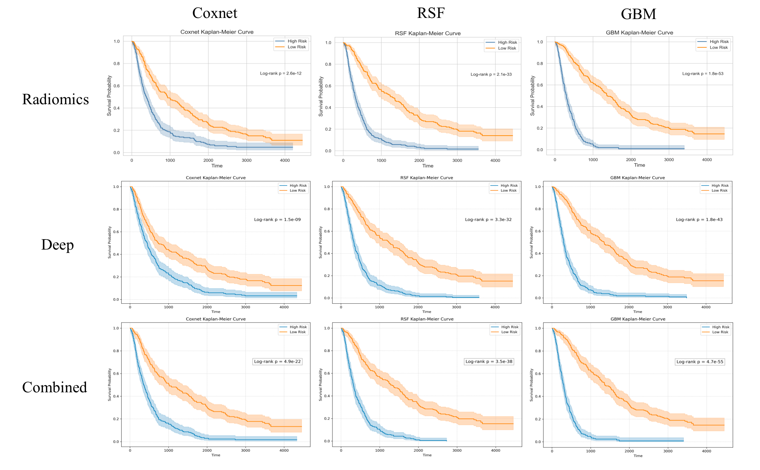
Figure 2 Kaplan-Meier Survival Curves for High-Risk vs. Low-Risk Groups Predicted by Different Models Using Various Feature Sets

3.3 Data Description
To enhance interpretability and understand the contributions of individual features to the survival prediction, SHAP (SHapley Additive exPlanations) analysis was applied to the GBSA model trained on both radiomics and combined feature sets. As shown in Figure 3, the SHAP summary plots reveal that texture and shape-related radiomics features are among the most influential predictors. Metrics such as autocorrelation, axis lengths, and diameter-related features exhibited substantial and variable impacts on model outputs, reflecting their relevance in capturing tumor morphology and heterogeneity.When deep learning features were integrated, several of them emerged as important contributors alongside key radiomics features. The combination of handcrafted and learned features enhanced the model’s capacity to represent both structural and high-level semantic patterns within the data. Notably, the interaction between the two feature types allowed for more nuanced predictions of patient risk.These findings underscore the biological and clinical relevance of the extracted features, particularly in reflecting tumor texture, shape, and latent imaging patterns. Moreover, the SHAP analysis confirms that incorporating deep features improves not only predictive performance but also the interpretability of the survival model by uncovering complex feature interactions that are not apparent from radiomics alone.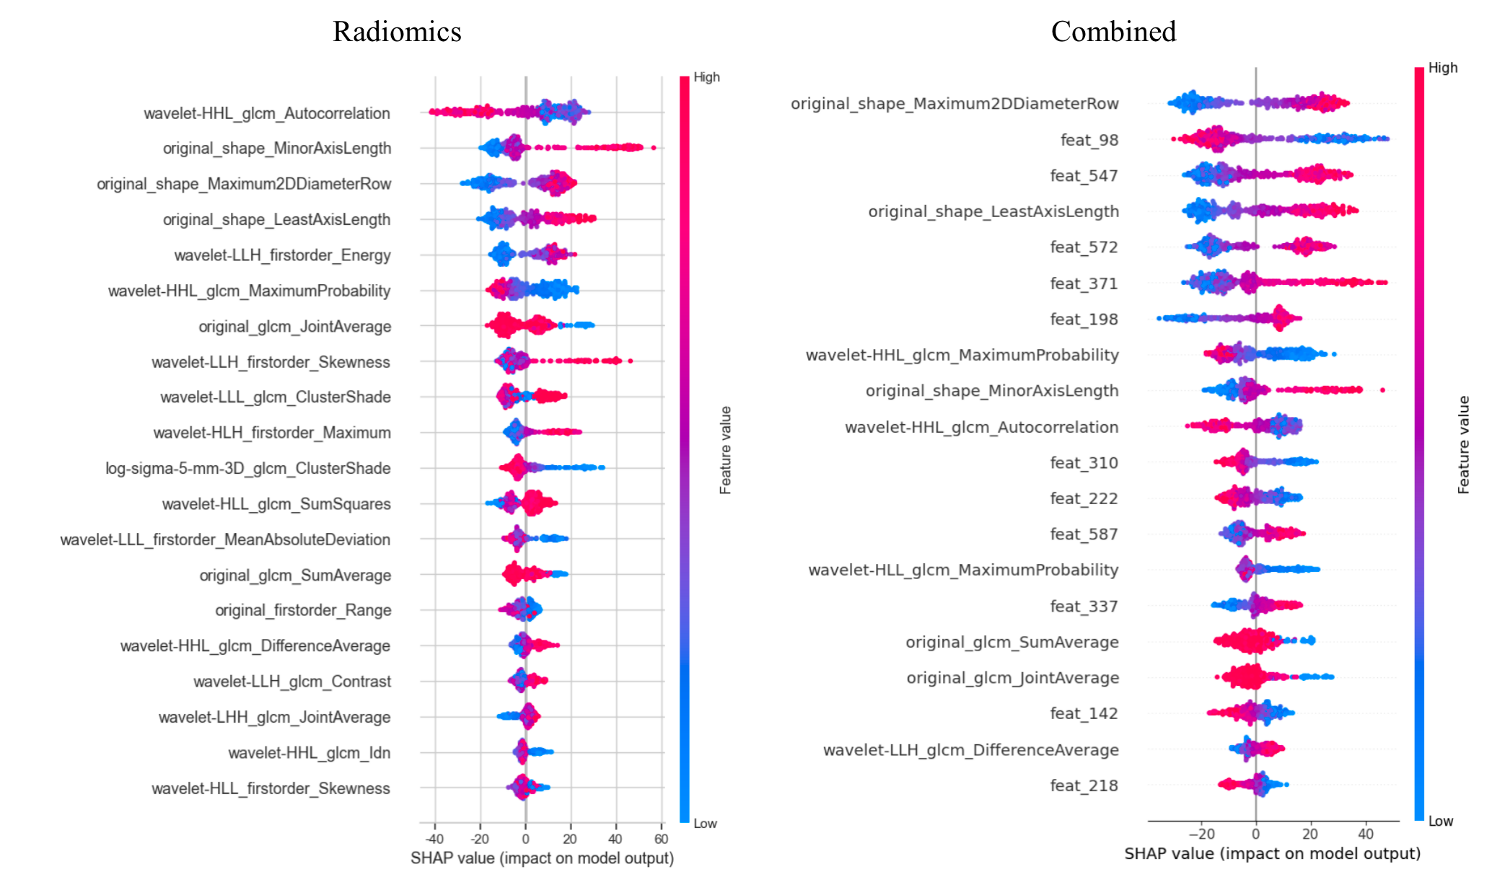

Figure 3 SHAP summary plots for the GBSA model using radiomics (left) and combined (right) feature sets.5 Conclusion
In this study, we developed and evaluated multiple survival prediction models for non-small cell lung cancer (NSCLC) based on radiomics features, deep features extracted from a Swin Transformer, and their combination. Feature selection using variance filtering and LASSO regression effectively reduced dimensionality while retaining informative predictors. Among the tested models, the Gradient Boosting Survival Analysis (GBSA) model demonstrated the most robust and consistent performance across all feature sets, achieving the highest concordance indices and the most significant risk stratification.Kaplan–Meier analysis confirmed the models’ ability to distinguish between high-risk and low-risk patients, with combined features leading to the clearest separation of survival curves. Time-dependent AUC analysis further validated the stability of model performance across different follow-up times. SHAP-based interpretability analysis highlighted the contributions of both handcrafted radiomics features and learned deep features, revealing that their integration enhances biological plausibility and clinical relevance while supporting more nuanced survival prediction.However, several limitations should be acknowledged. First, the relatively small sample size of the publicly available NSCLC-Radiomics dataset may restrict the generalizability of the results. Second, the current study did not incorporate clinical or genomic variables, which are essential for comprehensive prognostic modeling. Third, external validation using independent multi-center datasets was not conducted, limiting our ability to assess model robustness in real-world clinical settings.Future work will focus on addressing these limitations by expanding the dataset, incorporating clinical and multi-omics features, and performing external validation across diverse cohorts. This will facilitate the development of more generalizable, clinically applicable survival models for precision oncology.

